Software Setup for Servlets-JSP tutorial :

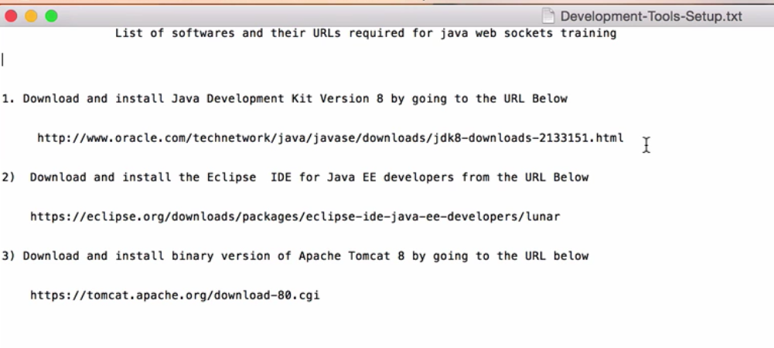
Install Java
Step 1: Download and install latest “Java SE Development Kit” (i.e. JDK) version “X” from
http://www.oracle.com/technetwork/java/javase/overview/index.html
by clicking on the “Downloads” tab. Select the “Java SE Platforms” and “Java” button.

Pick the Java SE Development Kit X Downloads, where “X” is the major version like 8, you will have the minor updates marked as say “u131“, etc.
Make sure that you download and install the right version for the operating system on which you will be running — for example Windows (32 bit or 64 bit), Linux, Solaris, MAC, etc. You will need both the JDK and the JRE.

Double click on the downloaded file “jdk-8u131-windows-x64.exe”, and follow the installation prompts.

Verify Java Installation

Step 1: Go to the installation folder, for example “C:\Program Files\Java\jdk1.8.0_121” to verify the presence of relevant files required for compiling & running Java.

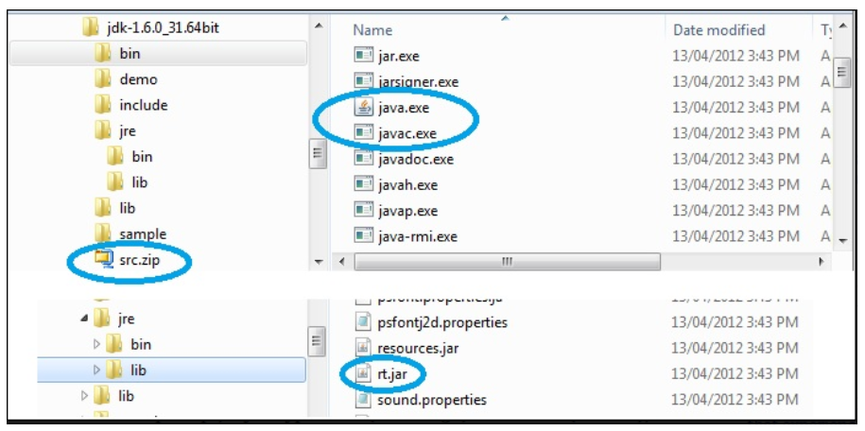
The javac.exe is the compiler that converts a source file (e.g. HelloWorld.java) to a byte code file (e.g. HelloWorld.class).
The java.exe is the run-time command to execute a program (i.e. java HelloWorld).
The src.zip is where all the Java API (i.e. Java library) source (i.e. .java) files are located and rt.jar is where the Java API run-time class files (i.e. class) are located.
Step 2: Open a DOS command prompt, and go to the folder “C:\tools\jdk-8u131-windows-x64\bin” and type.
cd C:\Program Files\Java\jdk1.8.0_121\bin
java -version

If you run the above command “java -version” from any other folder outside the installation folder “C:\Program Files\Java\jdk1.8.0_121\bin” it won’t recognize the command.
What if you want to run your *.java files from “C:\projects” folder? You need to set the environment variables to achieve that as shown below.

Configure Java to run from any folder for a given DOS session

Step 1: Set the environment variables. In setting up JDK and Java applications, you will encounter these environment variables:
1. PATH used by javac & java commands to discover JDK installation folders.
2. CLASSPATH used by javac & java commands to discover other Java classes.
3. JAVA_HOME used in defining PATH.
4. JRE_HOME used in IDEs like Eclipse to define the JRE directory location.

1) JAVA_HOME maintains the location of JDK installed directory. Similarly, JRE_HOME maintains the location of the JRE installed directory.

2) PATH stores a list of directories for searching executable programs. So, when type “javac” to compile or “java” to run a program from any directory, the operating system knows where to find these commands i.e. from %JAVA_HOME%/bin. If you don’t set the “PATH”, you can only run it from the JDK’s location under bin, which is very limiting.

Verifying the environment variables

In a command prompt, if you type “set” (in WIN 32) and “env” (in Unix), it will show all the environment variables.

You can verify if Java is set up correctly by typing the following command in a command prompt from any folder.

java -version

If the version is not displayed, then Java environment is not set up correctly.

The Java Compiler (i.e. javac) and Java Runtime (i.e. java) searches the CLASSPATH entries for Java classes referenced in your program.

Handy DOS commands

1. To check where Java is installed

C:\projects>where java

In Unix, use the command : which java

2. To inspect the environment variables “TOOLS_HOME”, “JAVA_HOME”, and “Path”

C:\projects>set

You can also “echo”
C:\projects>echo %JAVA_HOME%

Eclipse IDE step by step tutorial

Step 1: Download and install eclipse latest version into the “c:\tools” folder from
http://www.eclipse.org/downloads/
It is an IDE (i.e. Integrated Development Environment). This tutorial downloads Eclipse Neon. Get the EE (Enterprise Edition).

Configure JDK in Eclipse :

You need to tell Eclipse where JDK is so that it can use it to compile your classes.

Window -> Preferences -> Java -> Installed JREs (Eclipse will automatically pickup JRE from default Java folder).
Remove the existing one. Click on Add -> Standard VM -> Select the JDK folder where you would have installed JDK.
Installing Tomcat and configure in Eclipse :

Google for 'Tomcat 8 download'
Download the correspdong installer file.

https://dzone.com/articles/how-add-tomcat-8-eclipse

Start Eclipse and click on “Servers” tab in the workbench. Go ahead and try adding a new server.
You would find option for Tomcat 8 available for selection as shown below.

- After clicking Finish, you would see a new server added with the name as “Tomcat v8.0 Server at localhost”. Start the server.
- Check http://localhost:8080 (provided you installed Tomcat 8 and set Http port as 8080)
- Interestingly, you would NOT see the welcome page, but the 404 error page.

To get rid of that, Double click on ”Tomcat v8.0 Server at localhost”. In the window that opens up, select “Use Tomcat installation” and, change deploy path from wtpwebapps to webapps.

Look at the figure below.

- Restart the server and access http://localhost:8080 . You are all set.

Installing MySQL :

https://corlewsolutions.com/articles/article-21-how-to-install-mysql-server-5-6-on-windows-7-development-machine

MySQL on windows runs as a serivce on port number 3306.

Using MySQL workbench, I created Local database connection.
My root password is : chotu123
I created a new database with name 'mylocaldb'.

Any decent Java application will require a database.
All Java developers not only must know “SQL”.

Step 1: Download “MySQL” Zip archive (i.e. Windows (x86, 64-bit), ZIP Archive) from
https://dev.mysql.com/downloads/mysql/
and select “No thanks, just start my download” when prompted to “login or signup”, and extract the zip file into “c:\tools” folder.

Step 2: Now you have “C:\tools\mysql-5.7.18-winx64”. Add the MySQL to the windows path.
SET MYSQL_HOME=C:\tools\mysql-5.7.18-winx64\mysql-5.7.18-winx64
SET PATH=%PATH%;%JAVA_HOME%\bin;%M3_HOME%\bin;%MYSQL_HOME%\bin

Step 3: Initialize the database.

c:\scripts>mysqld --initialize --console

Note down the temporary password:
2017-06-28T10:59:35.902725Z 1 [Note] A temporary password is generated for root@localhost: yw0+k4e-rjlI.

If you make a mistake somewhere, DELETE the entire “C:\tools\mysql-5.7.18-winx64” directory, and REPEAT the steps from unzipping into “c:\tools”.

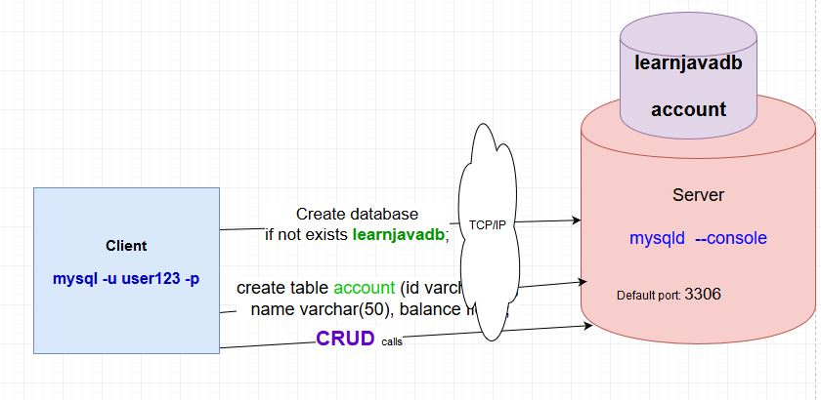
Step 4: Start the server.

c:\scripts>mysqld --console
Step 5: Start the client as a “root” user

c:\scripts>mysql -u root -p

You will be prompted for the password. Enter the one you previously noted down.

Step 6: Change password for ‘root’@’localhost’ with something that you can remember.

mysql> alter user 'root'@'localhost' identified by 'password123';

Create a New User : # create user , # new user

Step 7: The superuser “root” is privileged, which means for database administration and is not
running DDLs and DMLs.

So, let’s create a new user “user123” with a password “pwd123”

mysql> create user 'user123'@'localhost' identified by 'pwd123';

Step 8: Grant permissions to “user123”

mysql> grant all on *.* to 'user123'@'localhost';

Create a new database “learnjavadb” and a table “account” # create database

Step 9: Create a new database named “learnjavadb“.

mysql> create database if not exists learnjavadb;

Step 10: Display the databases.

mysql> show databases;
+--------------------+
| Database |
+--------------------+
| information_schema |
| learnjavadb |
| mysql |
| performance_schema |
| sys |
+--------------------+
5 rows in set (0.00 sec)

Step 11: Create a new table named “account“. # create table

mysql> use learnjavadb;
Database changed
mysql>

mysql> drop table if exists account;
Query OK, 0 rows affected, 1 warning (0.00 sec)

mysql> create table account (id varchar(30), name varchar(50), balance float);
Query OK, 0 rows affected (0.33 sec)

mysql> show tables;
+-----------------------+
| Tables_in_learnjavadb |
+-----------------------+
| account |
+-----------------------+
1 row in set (0.00 sec)

mysql>

Step 12: Describe the table.

mysql> describe account;

Step 13: Insert 3 rows.

mysql>insert into account values ('123', 'John R', 255.00);
mysql>insert into account values ('456', 'Peter Smith', 1234.00);
mysql>insert into account values ('789', 'Joanne R', 675.00);

Step 14: Select all the rows from the table “Account”.

mysql> select * from Account;

Step 14: Quit the client.

mysql> quit

Backup the database with the “mysqldump” utility program # backup database

Step 15: Backup the database.

c:\scripts>mysqldump -u user123 -p --databases learnjavadb > c:\projects\backup_learnjavadb.sql
Enter password: ******

Step 16: Restore the database.

mysql> drop database if exists learnjavadb;
mysql> source c:\projects\backup_learnjavadb.sql

You can now practice your SQL commands.

